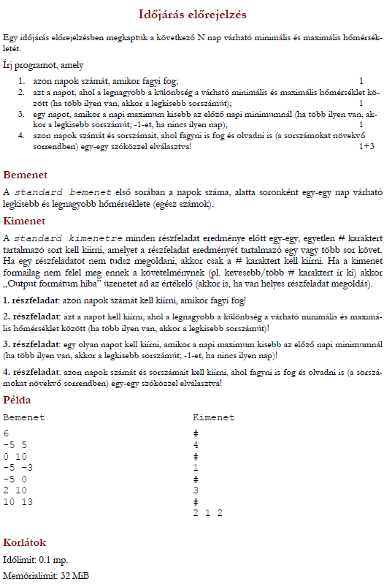

[SPECIFIKACIO:](https://progalap.elte.hu/specifikacio/?data=H4sIAAAAAAAACo1WzU7bQBB%2BlZFPRN1F2bUT2yuMFFRUKmgrQVtVhBwc7CCL4CASKhDi0Fveq2%2FCk1STZMfObLbtIZJ3J%2FP3zTez8xLM78vralJd54tqVgcmOCoN1G%2FL5WcBVTF7Wy5PZkO1v1%2BPBJzMsr27qjaX8AR3%2BZO57Fw9XNUXucHT7eN0Vo%2Fn5c3bcnmJ96eVgUl%2B81zn92tz7T9VdYH%2FE%2FAzr2%2BreTkevy2XZwLW3yQtxhvVcvpc3a5PGE0xHqGL44kBdZDV%2BP1tQu6y94PzwdFelWHcqzSG1Wj%2FrqrhIINuB%2FK6QA0AgD0W1HaUnezT4IdjJ38C2TK6bY%2FyaeXSyU6Pz48v0NA7x9TB%2BiBVY6wBBTKY5NN5CfKwMQcZSLXltBg3EHWy04%2Fff%2F86%2B%2FJh8NUHwcpJK4ZD6AqoVtUMRLAo54t5YIYvQZEv8sAEtYG0i8KqmBkYrt2%2BIBMg6q8Qw49X0RaE4UYQRtuCqGs19LZA9qxEpdsSnVoVZkuG5D7lkngjkanPP4tYWi%2Fcu%2FIErChFphFGHhdRYgUJ863JFnNio9UcX4sV%2B78mFzFHRFtENItXkY5iOlHPunfwtZKQ61gYNYuMahXGu1NxCKEsjqEDF1VXhyyXyFcUX7Wk7pIxpuKlChVSupDZ9Dn%2BFrAez7LnwYWS5KVs%2BMVwUR4SNZx3gPQ5l0p5mKdSb72sBsvDeg%2B7PtYnu0kfcgeWQjxYSlAqHq2tFJ9D1rVm99TVnL%2BtonMnEVWKdxbNDlZ1i6HiE40KIp3%2BTXfDKylF3guShoHipKNZK92ZSj3f80HJ%2BUgdzAKgkB1B14NLwzrO1FaJHRKnu2nUCKRTTGVLphkpbW85XqKQjPlUOL8j8s87UirtY4DykUlGNMGdGdZ0uNPHxAHOTWuNz3ZvOaXWHnI2rw7LxvuuaXoNeP6t2eqMSrLmDGTaHfg8Vj5kqDgcZ4I56r%2Fi%2FWrV3KyWaAaPbG00EDvXBpLVHS1zBhYPjyVe0SpnQOO5GOM7ujKw2eIMDCMBfYGDAp80fCRwjuIyglXAMYEPOtYKnwPsNMQAY48iAfhw427Ww18soJcI6HcF9GMB%2FVRAHAmIewLiWECcCEj6ApJYQJKMAhHU%2BV0ZmCAQwUM5f5wuAqNeRXsdVLu3wdYb5wKnduLm3GIbMdhWKzDDTSoLHMdN%2FVcG%2FX9msPNFclqcxjXvFStgCtpjiGiqNoYY63ww7Qb075wLLXSaQydA%2B9Abvf4BecXGASwOAAA%3D)

